**Upload Flat File(*.csv) into table:**

1. Create Project

2. Control Flow

2.1 Take Execute SQL Task

2.2 Make Connection to Northwind database (Server name, Database name)

2.3 Type query to truncate table in which importing data from csv file (Table: Region, Region.csv)

3. Drag and drop Data flow Task on control flow and link SQL task to it.

4. Double click on Data Flow task it will take you to Data Flow tab

5. Select Flat File Source from Other Sources and drop at Data Flow tab

5.1 Double Click on Flat File Source to make connection, select New and Browse the file loation

6. use Data conversion task if you need it otherwise select "OLE DB Destination" from Other Destinations

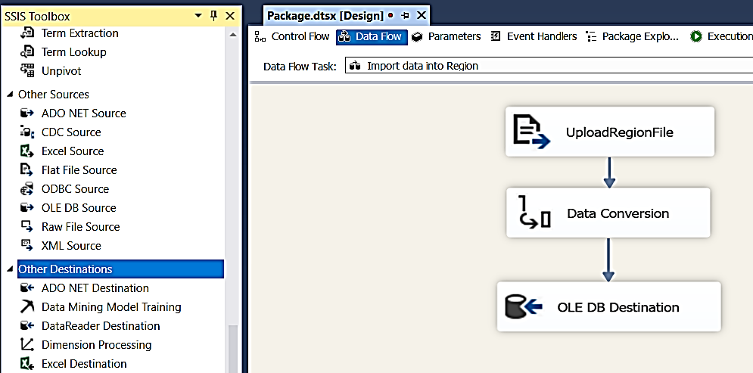

7. Build Project (short Key) F6

8. Run Project by clicking “Start”

9. Deploy project by right clicking on Project than Deploy

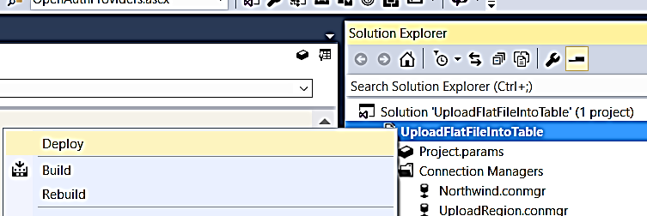

10. Open SQL Server Management Studio and make sure you have SSISDB database under Integration Services Catalog, If you don’t have than you can create one just Right Click and select “Create Catalog” and provide password

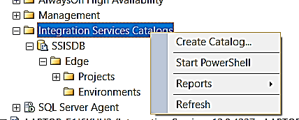

11. Once you have SSISDB, create a folder for you project to deploy

12. If your Project deployed successfully you will see under Projects folders

**Adding Parameters:**

13. Now go back to bullet [8] and add two parameters for file and database connection under Project

**Note:** Scope of parameters are on Package and Project, if you make parameter on package level it will be only visible for that project and if you make on Project level it will be available for all Packages under project.

Also if you select “Require” true, project will asked you the value every time you run the project, if you don’t want to provide this value than leave default i.e False

14. Select Project.params, than click on Parameter and create two Parameters

a. pfilename = \\LAPTOP-E1J6KUU3\TechnicalExp\SSIS\Edge\Source\Region.csv

(we just replace C:\ or any drive letter that is mapped with server name adding two “\\” in the beginning

b. pNorthwindDBConString = Data Source=LAPTOP-E1J6KUU3\MEHBOOB_SQL14;Initial Catalog=Northwind;Provider=SQLNCLI11.1;Integrated Security=SSPI;Auto Translate=False;

15. ReCompile and Deploy project

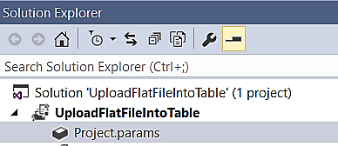

16. Again go back in SQL Server Management Studio and Select your Project – Right Click and Provide value for the Parameter manually (We will setup auto by using Environment variables)

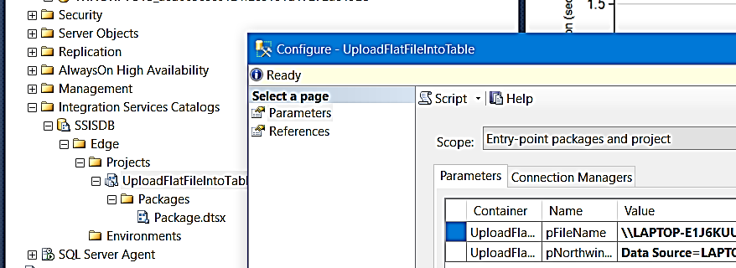

17. Right click on Package and execute – Package is working successfully, if you want to make it dynamic where you can change the file name and table name than you can use Environment variables

18. Create Environment for Parameters and variables (Go back to SQL Server Management Studio)

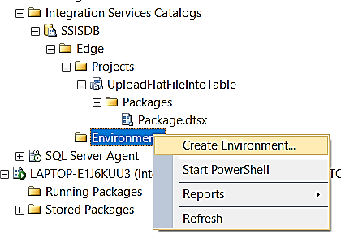

19. Create two Environment variables

a. vFileName = \\LAPTOP-E1J6KUU3\TechnicalExp\SSIS\Edge\Source\Region.csv

(we just replace C:\ or any drive letter that is mapped with server name adding two “\\” in the beginning

b. vNorthwindDBConString = Data Source=LAPTOP-E1J6KUU3\MEHBOOB_SQL14;Initial Catalog=Northwind;Provider=SQLNCLI11.1;Integrated Security=SSPI;Auto Translate=False;

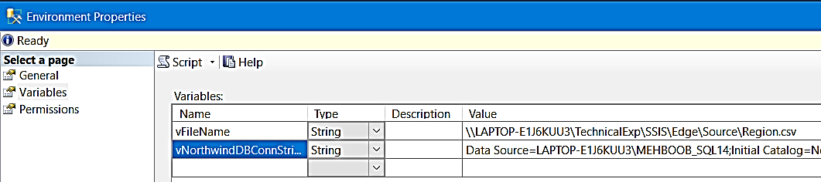

20. Now add references to Environment that you just created into your project

Select your Project – Right Click – Select “Add” than Select “Env for Parameters and Variables” - OK

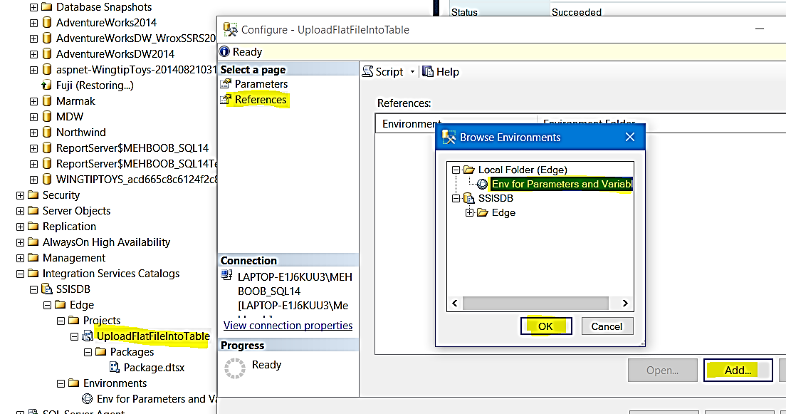

21. Next Step is to provide assign Parameters value to Environment variables

You have to assign pFileName = vfileName and

pNorthwindDBConnString = vNorthwindDBConnString

Select Parameters – click on […] – checked [Use environment variable] – Select the variable you are assigning to parameter and then OK

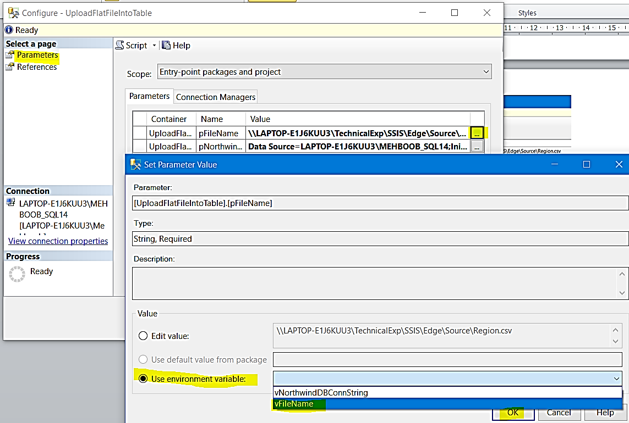

You will see following screen after assigning all values

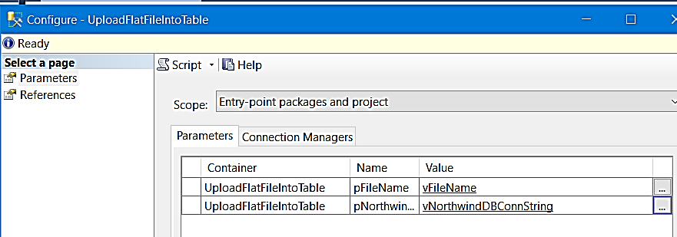

22. We have select parameters value “Require” True therefor every time when we run this project it will asked for values, if you don’t want this you can either select “Require” False when you setup parameters or you can skip Environment variables option.

**Setup SQL Server Agent Job:**

1. Open SQL Server Management Studio and right click on “SQL Server Agent” – New – Job

2. Select following three options from left

a. General: Define Job name

b. Steps: Define Package(s) which will execute in this job, if there are more than one you can include in Steps

c. Schedules: define when the job will execute

